Install and Full Screen:

<https://youtu.be/-CIepTSsaNE>

**Linux Commands:**

**List: ls**

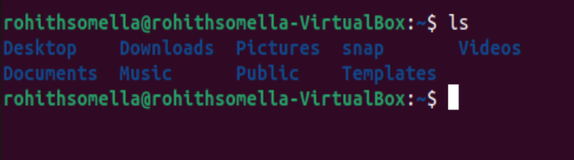

**Dictionary: directing to any file we use: “cd” before any folder name**

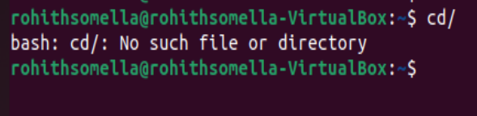

**Open any: cd: change directory**

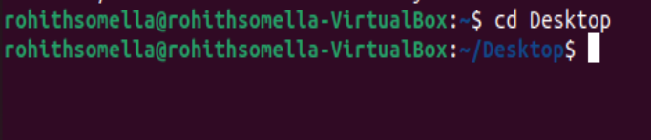

**Go back from opening any: cd or cd..**

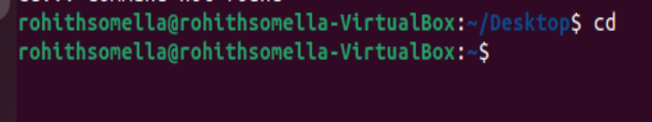

**Present working directory: pwd**

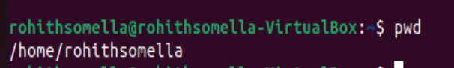

**Directly we can go to sub folder or file by using slash “/” between each level**

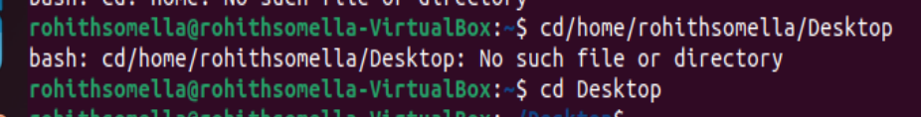

**Create New file with any extension: touch filename.txt**

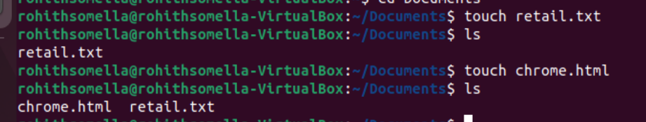

**Multiple file creation at a time: touch files to create**

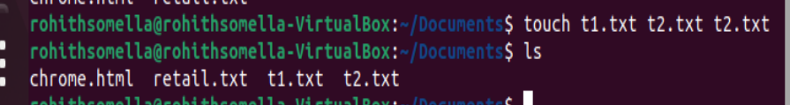

**String will get print on the terminal: echo “string value”**

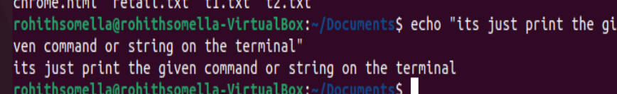

**Adding string into a file: echo**

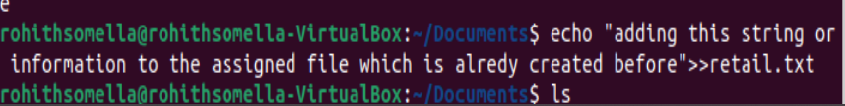

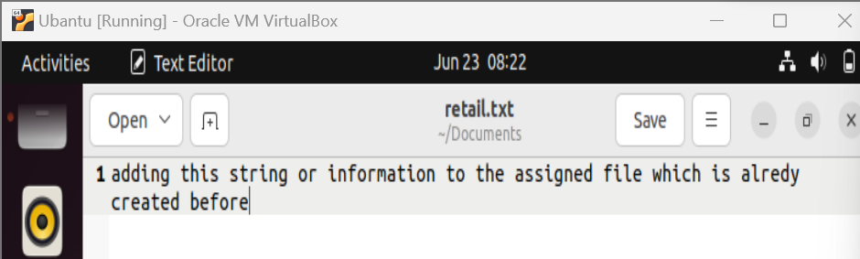

**Over write the new string**

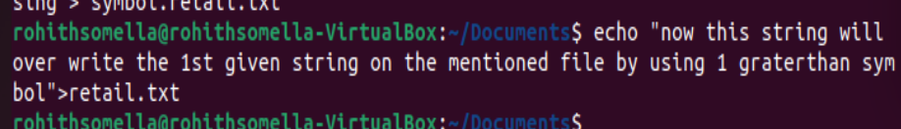

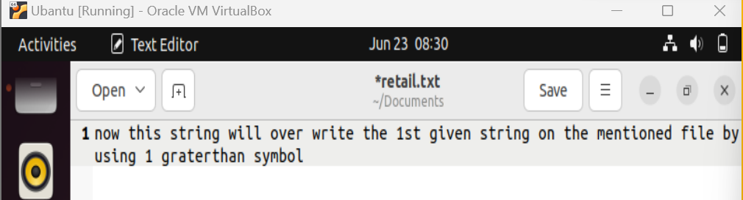

**Bring out the information from the file on terminal: cat file_name**

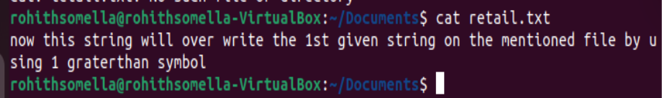

**Nano terminal: used to edit the mentioned file**



**Nano Terminal:**

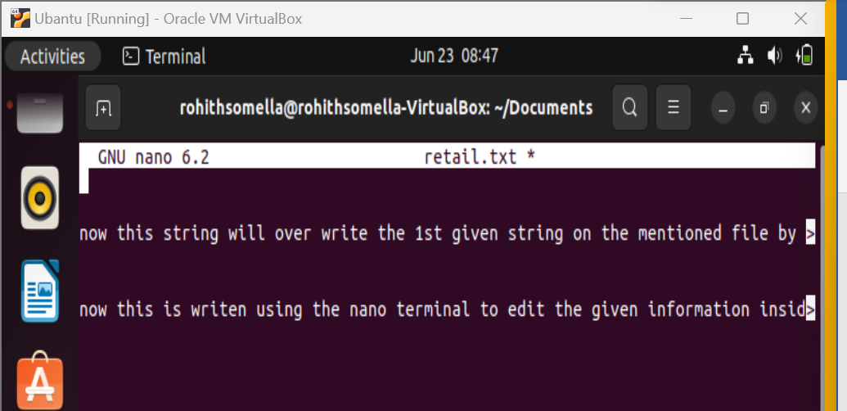

After writing the information we must save that information inside the file for that we have to use cont+O to wite out means writes the information we have written in the nano terminal

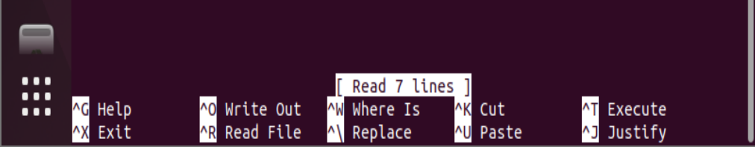

After writing the file go for exit for that use cont+X to come out now it will ask

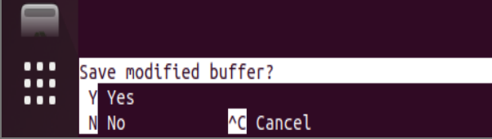

Now press y to save the file then press enter button

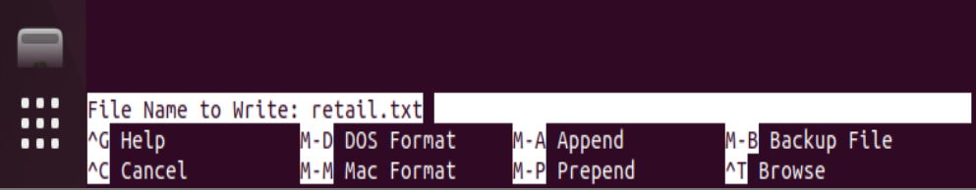

to come out of the nano terminal to the original terminal

Day 3:

**--------------------------------## YouTube @vamshi Bhavani Linux Commands ##--------------------------------**

**Important Commands:**

<https://youtu.be/qjlwbS8SGEA>

**for hidden files: ls -al**  
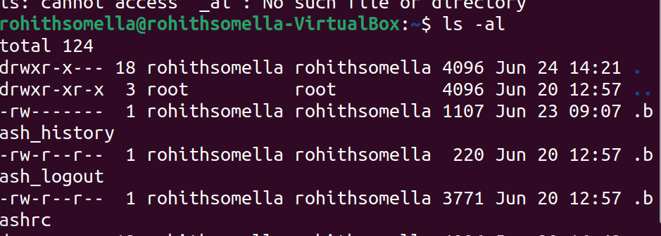

**Create a folder: make directory: mkdir**

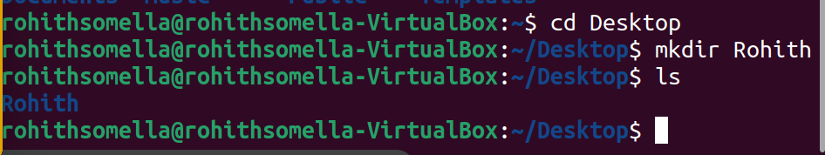

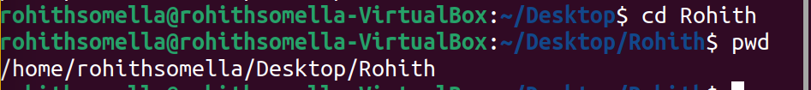

**Remove files rm ocean.txt**

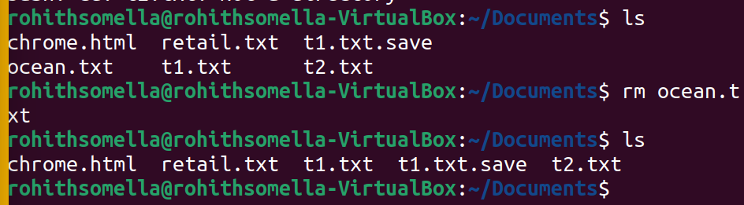

**Remove Folder: rm -r folder_name**

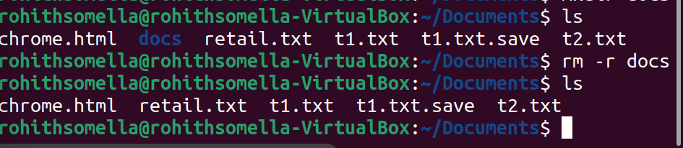

**HELP in Linux on any command:**

**Command --help**

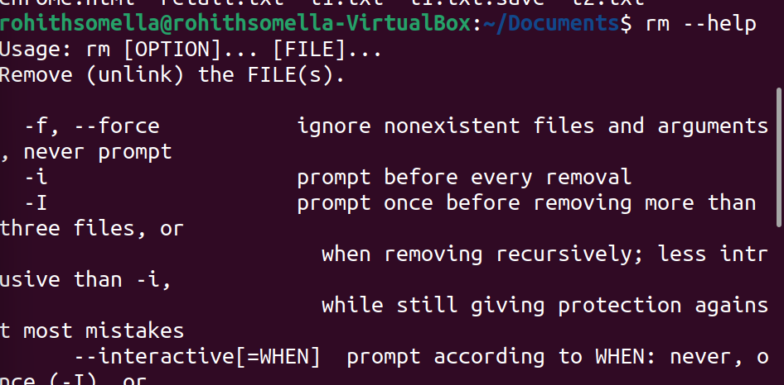

**Clear the console: clear**

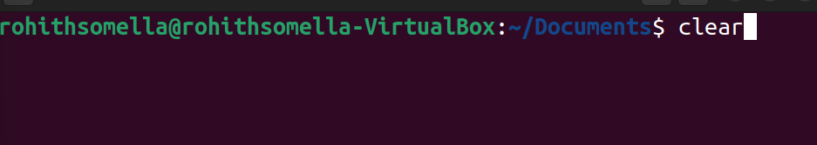

**How to create a new file with information in it: cat > t2.txt**

**Stop and save use cont+d**

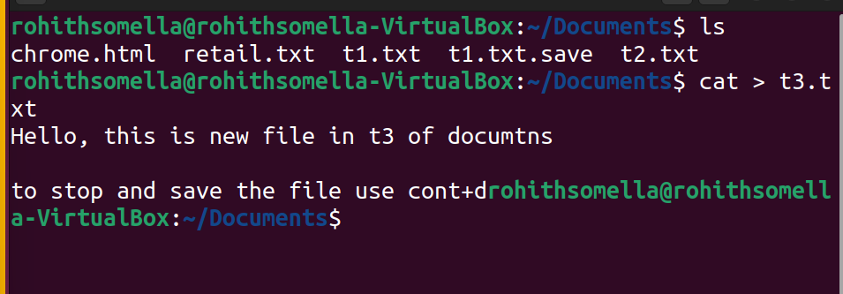

**Copy 1 file information to another file information:**

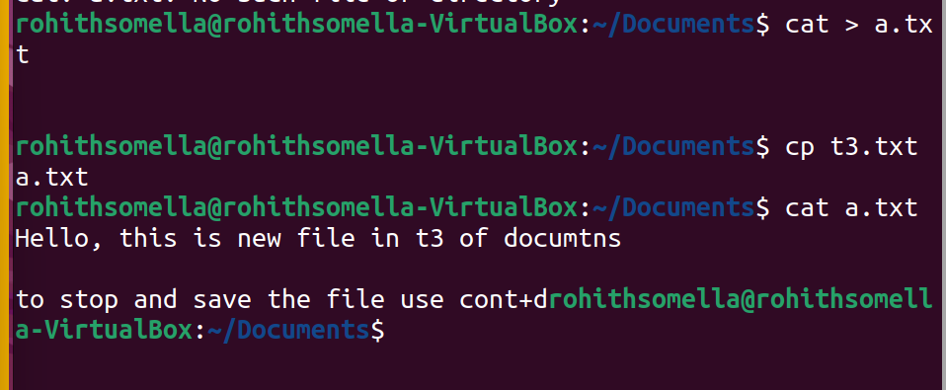

**Now if we want to create a new file for coding like python Extension:**

Use: vi hi.py 🡪 it is a **vi function** just like cat function for creating txt extension files

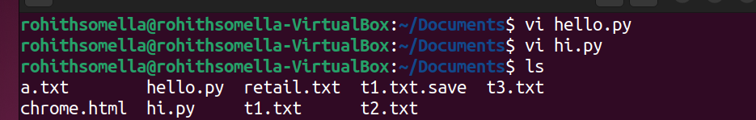

Press Enter after vi hi.py command

Then you will redirect to the created file to write any code inside of it but for that you need to enter “I” it represents INSERT option/

So, once you have Entered “I” no you can write any code of your choice then

If you want to save the code hit ESC (escape) button then use

**:wq**  
then enter so now file is saved with given code.

**Rename the file: mv old_file new_file**

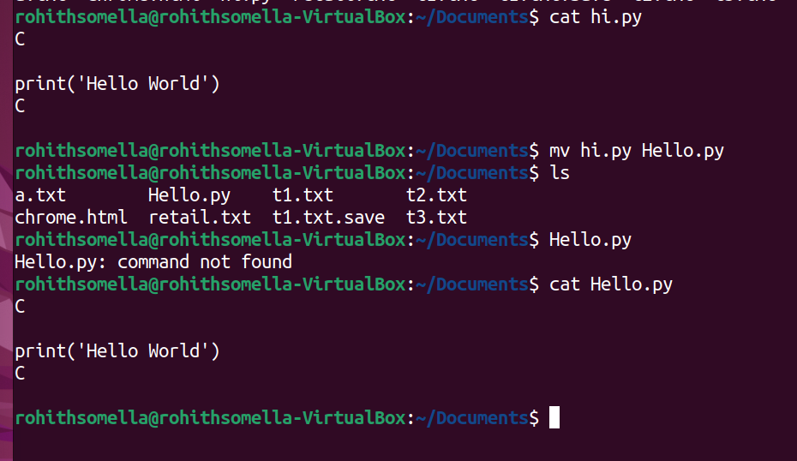

**Device Info: ps**

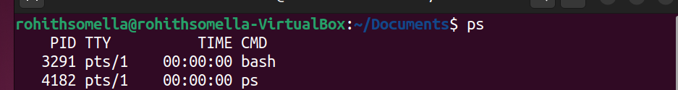

**top**

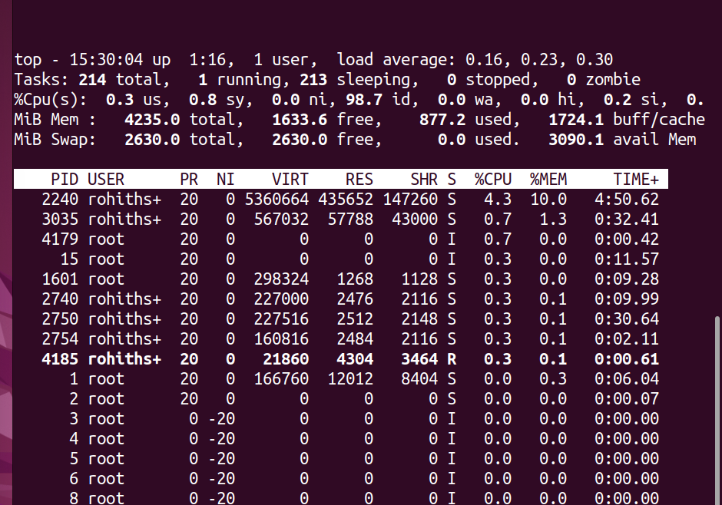

**Press cntrl + c to come out of this**

**To kill any processing:**

kill PID: kill 15 (kill PID_number)

**to see if something running in the background: bg**

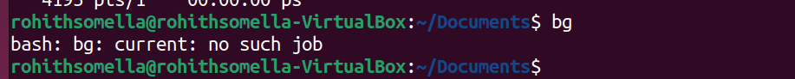

**Foreground running or most recent: fg**



**Giving permission to owner, group and public using: chmod 19:05 – 20:30 *time stamp in video***

**Ping: it gives the posibilityes to connect to the given website and give information of it**



**Date: date cal**

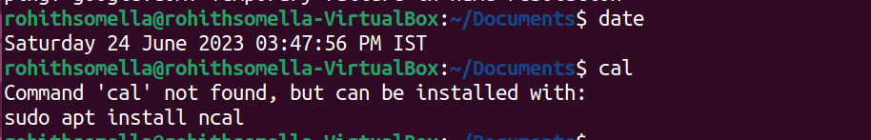

Usually, it should get like this

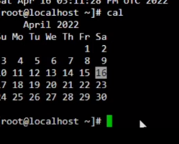

**Uptime:**



**To check the users online just hit: w**

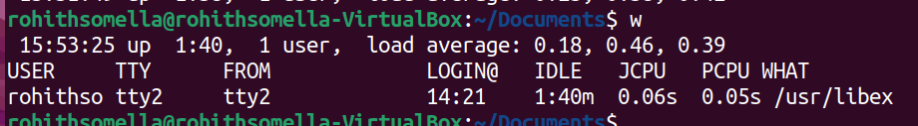

**To know the user Name: whoami**



**Information of the given user: finger**

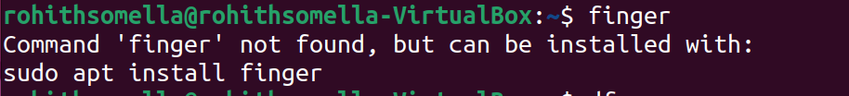

**Disk Information: df**

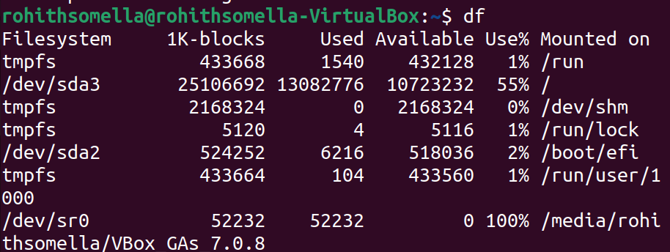

**Check the usage and free space: free**

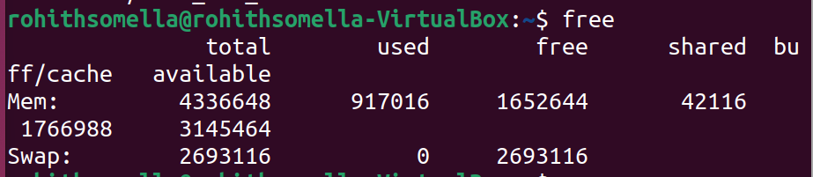

**Ctrl + u to remove the line in the console**

**Ctrl + d to come out of the session**

**Ctrl + w removes the word**

**Exit: used to logout the session**

**Tar cf filename.tar filenames: used to compress the files**